Programming Concepts- Tutorial 4 Solutions
HIT265 – C Programming
Note: Only the final trees are given in the solutions below. You should show the tree at each stage in your answers.
Question 1
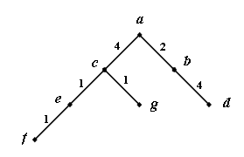
Apply Dijkstra’s Algorithm to each of the graphs in Figure 1. Don’t forget to include the table of vertex labels and the tree at each stage in your answer. In the graphs where no edge weights are given, assume an edge weight of 1 for each unlabeled edge. Remember to use the alphabetic/numeric convention – this will tell you at which vertex to start the algorithm.
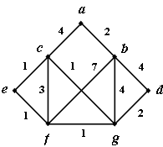
(a)
T_{a}

order | L(a) | L(b) | L(c) | L(d) | L(e) | L(f) | L(g)
a | 0 | 2 | 4 | ∞ | ∞ | ∞ | ∞
b | - | - | 4 | 6 | ∞ | 9 | 6
c | - | - | - | 6 | 5 | 7 | 5
e | - | - | - | 6 | - | 6 | 5
g | - | - | - | 6 | - | 6 | -
d | - | - | - | - | - | 6 | -
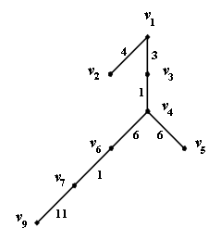
(b)
T_{b}
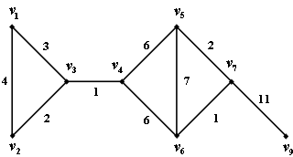

order | L(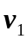) | L(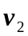) | L(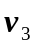) | L(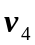) | L(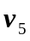) | L(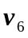) | L(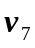) | L(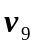)
 | 0 | 4 | 3 | ∞ | ∞ | ∞ | ∞ | ∞
 | - | 4 | - | 4 | ∞ | ∞ | ∞ | ∞
 | - | - | - | 4 | ∞ | ∞ | ∞ | ∞
 | - | - | - | - | 10 | 10 | ∞ | ∞
 | - | - | - | - | - | 10 | 12 | ∞
 | - | - | - | - | - | - | 11 | ∞
 | - | - | - | - | - | - | - | 22
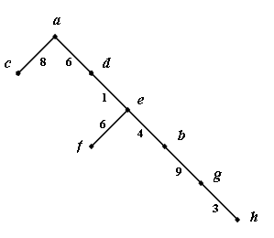
(c)
T_{c}

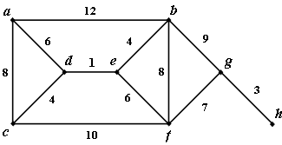

order | L(a) | L(b) | L(c) | L(d) | L(e) | L(f) | L(g) | L(h)
a | 0 | 12 | 8 | 6 | ∞ | ∞ | ∞ | ∞
d | - | 12 | 8 | - | 7 | ∞ | ∞ | ∞
e | - | 11 | 8 | - | - | 13 | ∞ | ∞
c | - | 11 | - | - | - | 13 | ∞ | ∞
b | - | - | - | - | - | 13 | 20 | ∞
f | - | - | - | - | - | - | 20 | ∞
g | - | - | - | - | - | - | - | 23

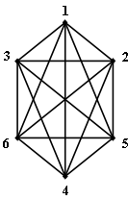
(d)
T_{d}
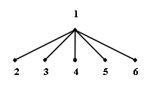

order | L(1) | L(2) | L(3) | L(4) | L(5) | L(6)
1 | 0 | 1 | 1 | 1 | 1 | 1
2 | - | - | 1 | 1 | 1 | 1
3 | - | - | - | 1 | 1 | 1
4 | - | - | - | - | 1 | 1
5 | - | - | - | - | - | 1

Question 2
What is the complexity of Dijkstra’s Algorithm? (We will cover this in class later, but try to think this through on your own first).
Complexity: 

